NEW Product Press Release

WingKey™ Systems announced today the release of a NEWLY Re-designed All-in-One “WingKey™”

San Jose, California, January 19, 2006: Just released, this revolutionary all-in-one newly re-designed tool that can help drummers and percussionist alike, to securely tighten and loosen the numerous wing nuts found on hardware stands, clamps and accessories through out the musical hardware world… and more!

The “WingKey™” provides a compact, sturdy and practical device for conveniently tightening, and loosening wing nuts, as well as, giving the artist the ability to tune percussion instruments of all kinds. It incorporates a multi functional design to be able to tighten and loosen wing nuts, as well as, tune drumheads. The “WingKey™”has a standard “drum key” socket on one end of the handle to accommodate any standard drum lug nut. The body has a hexagon ½ inch standard socket on one end, for tuning congas, bongos and timbales, and can also be used on all ½ inch nuts such as on clamps, rack systems and seat thrones. The other end has a double slotted end to accommodate both large and small wing nuts. This device will provide a mechanical advantage, typically inventoried in a gig bag used by most techs, drummers, percussionists, and artists. “Using the “All-in-One WingKey™” will make tightening and loosening wing nuts with pliers a thing of the past, eliminate the damage to wing nuts associated with using pliers and will be much less harmful to the hands and fingers,” said, Frank D. Parise, inventor and owner. He went on to say “this device provides a practical means for facilitating tightening and loosening of wing nuts, as well as, the tuning of numerous kinds of drums into a much easier, less harmful and effortless procedure… while providing a ½ inch socket wrench… all-in-one tool… a must have for all techs, drummers and percussionists alike ”.
For further information on the NEWLY designed all-in-one “WingKey™”
Call either: 408-225-7814 or 650-218-3436 (cell)
On the web at: www.wingkey.net Email: fdparise@sbcglobal.net

Authorized For Immediate Release, January 19, 2006

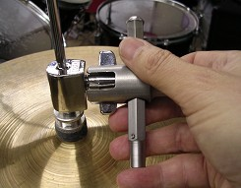
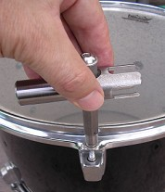
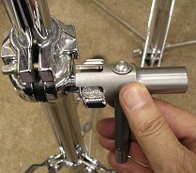
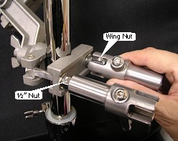

Tighten & secure that stand
Tighten & secure that hi-hat
Tighten & secure clamps & racks
Tune your drum heads
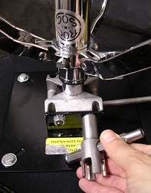

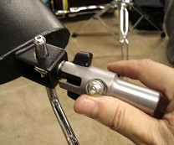
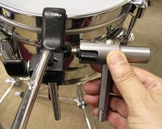
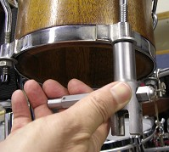
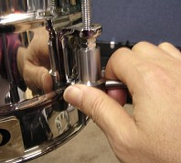

Tighten & secure your ROC-n-SOC seat
Tighten & secure “claw clamps”
Tune timbale heads
Tune conga & bongo heads
Tighten & secure cow bells, blocks, etc.

