NEW Distribution Product Press Release

WingKey™ Systems and Gibraltar Hardware announced today the release of the All-in-One “WingKey™”

San Jose, California, January 15, 2009: Just released, WingKey™ Systems announced that it has teamed up with Gibraltar Hardware (Kaman Music), to produce and distribute the revolutionary all-in-one WingKey™ tool, and has added the tool to Gibraltar’s 2009 Service Center lineup. The WingKey™ helps drummers and percussionist, to securely tighten and/or loosen the multitude of wing nuts found on hardware stands, clamps and accessories throughout the musical hardware world… and more!

The “WingKey™” is a compact, sturdy and practical device for conveniently tightening, and loosening wing nuts, as well as, giving the artist the ability to tune percussion instruments of all kinds. It incorporates a multi functional design to tighten and loosen wing nuts, as well as, tune drumheads. The “WingKey™”has a standard “drum key” socket on one end of the handle to accommodate any standard drum lug nut. The body has a hexagon ½ inch socket on one end, for tuning congas, bongos and timbales, and can also be used on all ½ inch nuts found on clamps, rack systems and seat thrones. The other end is double slotted end to accommodate both large and small wing nuts. “Using the “All-in-One WingKey™” will make tightening and loosening wing nuts with pliers a thing of the past, eliminate the damage to wing nuts and will be much less harmful to the hands and fingers,” said, Frank D. Parise, inventor and owner. He went on to say “now that we have teamed up with Gibraltar Hardware, drummers and percussionists all over the US and global markets will have access to the WingKey™ the all-in-one tool, a must have for all techs, drummers and percussionists alike”.
For further information on the “WingKey™” Contact: fdparise@sbcglobal.net

WingKey Systems: 408-225-7814 www.wingkey.net Frank at: 650-218-3436 (cell)

Gibraltar- KMC Music: 860-509-8888 www.gibraltarhardware.com

Authorized For Immediate Release, January 15, 2009
Gibraltar / WingKey

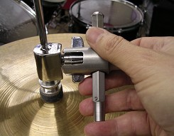
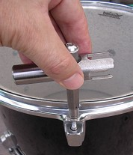
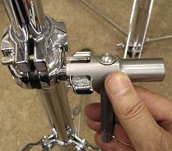
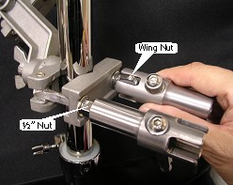
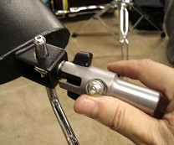
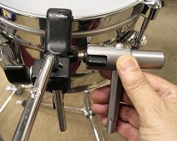
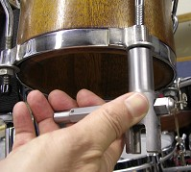
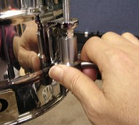
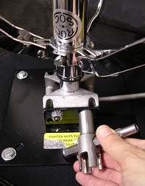
Tighten & secure that hi-hat
Tighten & secure clamps & racks
Tighten & secure that stand
Tune your drum heads
Tighten & secure your seat
Tighten & secure “claw clamps”
Tune timbale heads
Tune conga & bongo heads
Tighten & secure cow bells, blocks, etc.

Reviewed and spot lighted in MODERN DRUMMER… July 2006, Oct. 2006 & Nov. 2007

