NEWS Product Press Release

WingKey™ Systems makes news again with All-in-One “WingKey™”

San Jose, California, January 17, 2008: Once again, the WingKey has enjoyed another major product review/highlight in the November 2007 issue of Modern Drummer, by having been included in the “Handy Helpers… Gadgets and Gear That Can Make Your Life Easier” ! In the October 2006 review, Rick Van Horn (Senior Editor of Modern Drummer), opens with “Believe me when I say… YOU need a WingKey” ! and closes with “Get one”. The WingKey is a revolutionary all-in-one tool that helps drummers and percussionists alike, to securely tighten and loosen the numerous wing nuts on hardware stands, clamps and accessories through out the musical hardware world… as well as, tuning drums, congas, bongos and timbales.

For further information on the “WingKey™” …visit us on the web at: www.wingkey.net
Contact: Frank D. Parise - 408-225-7814 or (cell) 650-218-3436 - Email: fdparise@sbcglobal.net

Authorized For Immediate Release, January 17, 2008
July 2006
Oct 2006
Nov 2007



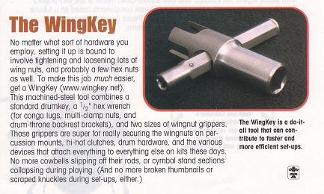

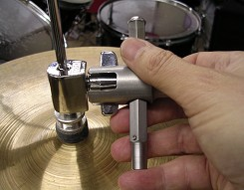
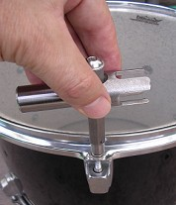
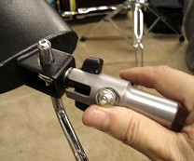
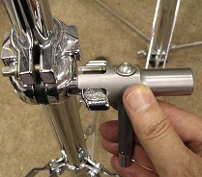
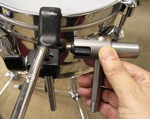
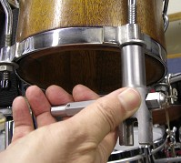
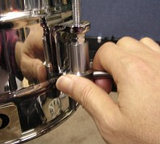
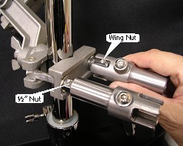
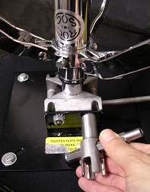
Tighten & secure that hi-hat
Tighten & secure clamps & racks
Tighten & secure your ROC-n-SOC seat
Tighten & secure “claw clamps”
Tune timbale heads
Tune conga & bongo heads
Tighten & secure cow bells, blocks, etc.
Tighten & secure that stand
Tune your drum heads

